Website Performance  Snapshot | Prepared by: [Your Name]  Local Website Performance & Visibility
[Business Name of Prospect]  [Website URL]  [Date] | Purpose: A clear, professional snapshot of how your web site is performing and where business may be lost due to speed, search visibility and underlying technical issues.
Performance Overview -- Based on current performance testing and observable site behavior.
Performance Score | Best Practice / Search Visibility | Page Size (Max Ceiling = 4 MB)
______ % | ______ score | ______ MB

Recommended Load Time | Your Current Load Time | Estimated Visitor Loss Risk
1.3 – 1.8 sec | ______ sec | Moderate / High

Key Findings  • Images are not optimized, increasing load time  • Unnecessary scripts are slowing overall  performance  • Page structure may be limiting visibility on  Google  Other Observations  • Headings and page structure could be improved for better search visibility  • Meta titles/descriptions may not be fully optimized for search results  • Some pages may not be clearly signaling their purpose to search engines | What This Means  Load time latency (sluggishness) results in visitors leaving the page before the website fully loads.  Script, structural and signaling issues result in the site not appearing as often as it should in Google search results.  Important Note  These issues can be corrected and are currently limiting how effectively the site performs and attracts visitors.

Looking forward to walking you through exactly  what's causing these issues and how to correct it. | Contact:  [Your Name]  [Phone Number]

This is just a snapshot of how the site is performing. See page 2 for full metric reporting
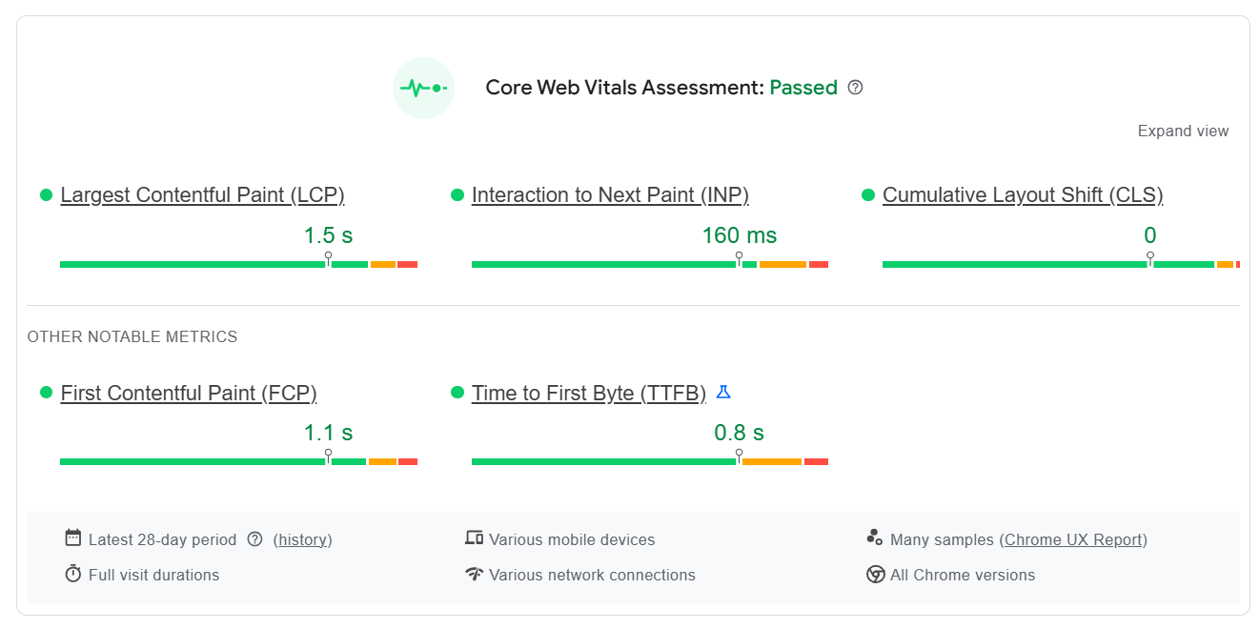
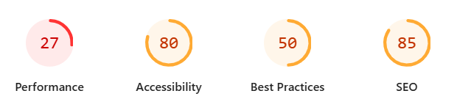


Diagnose performance issues – See results at https://pagespeed.web.dev

Most websites are slow — even major brands. We build sites correctly from the start, so that performance, speed and visibility isn’t a problem later
Showing results for URL: https://yahoo.com/
Report from Apr 15, 2026, 10:19:04 AM
How to use the Website Performance Report
NOTE: Our business of web design and development runs on trust —arguably more than most industries.
When someone hires you for their website and online visibility, they’re putting their business in your hands. Because of that, trust often matters more than price—and people will pay more when they feel confident in who they’re working with. That’s why in-person sales is so effective. It removes uncertainty and builds credibility immediately.
The following sample dialog is designed for in person presentation. (the quickest path to building trust) If you would like to modify this for email, text or letter writing campaigns, ask AI for assistance with the conversion.

Hi, my name is... I work with local businesses on their websites—mostly around speed and visibility in Google.
I took a quick look at your site and ran a performance check, and a couple things stood out that could be costing you visitors.
I printed it out so it’s easy to see—would you be open to me showing you real quick what’s going on with your web site?
After they say yes, immediately point to 1 or 2 clear issues (don’t overwhelm them):
- Right here (circle it) — this load time is over X seconds. Many visitors will leave before the page finishes loading. This is one of the things that puts you at moderate to high risk of losing customers.
- Also, Google actually factors this into rankings, so it affects how often you show up.
- And, of course, your page size (circle it) has far exceeded what the browser would normally expect to process, and so that just slows everything down. This is where you lose credibility with Google.
Has anyone ever gone over this with you before? (PAUSE, let them respond)
I would be happy to explain how I can resolve these issues for you. And the good part is, there is no charge until you see significant improvement to your performance scores. I’d like to start with just your load time unless you’d prefer that I look into revamping everything.
If they decline your offer, let them know that they can keep the analysis report and show them where they can run the same report at https://pagespeed.web.dev
—just type in your website address and it will show you the same stats.
And if you decide you’d like help with any of this down the road, my contact info is right there on the report.

