Practice Guide - Student Handout
Artificial Intelligence Website Workflow = Speak → See → Sell

Proprietary to the System
NOTE: This document, including all text, processes, and methodologies described herein, is confidential and proprietary to Creative Business System at jwwebsites.com and constitutes protected intellectual property. Any unauthorized access, copying, reproduction, distribution, disclosure, or discussion of this material, in any form, is strictly prohibited without the express prior written consent of Creative Business System.

How it works. Simple language is all it takes.
You talk. → The system builds. → A sell-ready page appears.
Describe what you want in plain language. Copy the AI output. Paste it into our protected areas. Publish. Done!

Your Practice Environment (2 modes)
JW website Artificial Intelligence Mode using the Vantage Theme: (Your default sandbox) Serious building for performance and speed.
Divi Commercial Product using the Divi Theme: A place to have fun using drag and drop user interface; Get serious if you like.
Chose the environment you like the best.
Switch anytime: From your WordPress Dashboard – Follow instructions on page 6 to switching Between Vantage and Divi.

The Core Workflow (Overview)
- Open ChatGPT and speak to the prompt.
- Copy AI's full output.
- From the WordPress Main Menu click the JW-websites Proprietary AI System and Paste code.
- Click Save Blocks and visit site to view the page in your browser.
- Check your new website on desktop / tablet / phone).
If the layout is what you want, you’re done. If not, request a revised version by saying: “AI, Please fix the section you created earlier. Here is what looks wrong:” [describe what you see or paste a snippet of the error]

The Core Workflow using the Prompt Generator (Overview)
  - Get your Industry “DNA” → Plug it into the Prompt Generator form.
  - Run the Form → Plug it into AI.
  - Run AI → Plug it into your web site.
Afterwards, use WordPress to organize / customize your Header, Footer and Menu.
Image Preparation Guidelines

AI can locate free images if you request them in your prompt, but relying on randomly sourced images often results in lower-quality visuals that make a website look less than professional. A better approach is to create your own high-quality images using AI by describing the image you want or by providing a sample image and asking AI to generate something similar. Once your images are created, they should be optimized before adding them to your website. A free program that works well for this is XnConvert. This program allows you to batch optimize several images at once using custom presets. It is a must have for our process. Large images slow down your website. Resizing them to the correct dimensions and converting to WebP significantly reduces file size without sacrificing quality. Faster pages improve user experience and send strong signals to search engines, helping boost performance and rankings.

How to setup and use XnConvert:
We use 2 presets:
- Hero Images
Set width to 1500px
Use for large top-of-page banner images
- Regular Images
Set width to 1200px
Use for standard content images
How to create a preset:
Open XnConvert
- Click Actions
- Add Action > Transform > Resize
- Enter the width and height:
  - 1500 X 1500 for hero images
- Keep aspect ratio turned on
- Enlarge / Reduce = Reduce only
- Click the Output Tab
- Set format to WebP
- Choose where the new files will save
- Test on one image
- Click small icon that says: Save the preset (assign a filename)
- Repeat the process for 1200 X 1200 for regular images
How to use a preset:
- Add your images
- Choose the preset
- Click Convert

After optimizing the images, upload them to WordPress: From the WordPress main control panel click Media → Add New → Select Files and upload your optimized images to the media library. After uploading, click the image in the Media Library and click Copy URL to Clipboard. From here you can paste them into Section 16 of your Prompt Generator form. The first image listed in your prompt will be used as the hero image at the top of the page. Any additional images will be placed elsewhere on the page where AI determines they fit best.

Replacing images in the Media Gallery
Replace any existing image with a new one on your website by clicking on that image in the Media Gallery and then clicking Upload a new file.

OTHER TIPS FOR USING AI TO PRODUCE IMAGES
When requesting Photo Stock images ask AI to generate the prompt for you. For example, instead of simply saying: ”AI, please give me an image that would work well on my Day Care web site.”
Say…
“AI please give me instructions for writing the best prompt for an image for my Day Care web site.” AI may return a prompt like this one for you to copy and paste back into the prompt:
- Subject: A warm, welcoming childcare environment with young children engaged in learning and play.
- People: A diverse group of children and a caring adult instructor. Everyone should appear natural, relaxed, and genuinely engaged. No exaggerated expressions. No staged or cartoonish poses.
- Environment: A clean, modern childcare classroom with soft natural light coming from large windows. Neutral walls with subtle, cheerful accents. Toys, books, and learning materials should look realistic and gently used—not perfectly staged.
- Mood: Safe, nurturing, and trustworthy. The image should make parents feel comfortable and confident.
Obviously, these detailed instructions would return a better image, especially if you provide further details using your own creative thinking.

Here’s another example of an AI written prompt that I use as a template for generating high quality imagery.
AI, please render Ultra-realistic professional stock photography. The imagery should be sharply focused with realistic depth of field, natural color balance, and even lighting. Textures—such as fabric, skin, metal, stone, and foliage—appear detailed and lifelike. The overall composition resembles a high-quality commercial stock photograph intended to convey professionalism, home services, safety, and positive customer interaction. The image is captured with a full-frame DSLR camera. Natural lighting, realistic shadows, true-to-life color balance, and accurate physical proportions. Sharp focus, high dynamic range, and fine detail with no visible grain or
noise. Skin texture appears fully natural with pores, subtle imperfections, and tonal variation. Materials, tools, and clothing look authentic and physically correct. Depth of field is realistic and optically accurate. The image should be indistinguishable from a real commercial stock photo used by major agencies.

Beyond the Basics
How to create your own pages and add new keys using the JW-websites Proprietary AI System.

Create a new Protected Page

Every page (or block) must be protected. WordPress, the Vantage theme, and other web-building systems flag AI-generated code as foreign and actively interfere with it, even crippling it if left exposed. Defending that code is not optional. This built-in defensive mechanism is what makes our proprietary system work. This section explains how the AI code is protected and how to create a new protected page.

- Log in to WordPress [your student sandbox site].
- From the WordPress Main Menu click Page → Add Page → SiteOrigin.
- Add your Title. For simplicity, begin with conventional page titles that visitors immediately recognize. Examples: Pricing, Testimonials, How it Works, Portfolio, Meet Our Team, etc. (Note: Unless you delete your previous pages, do not replicate pages that are prebuilt into the system ie. Home, About Us, Services, FAQ’s, and Contact) Using simple titles makes it easier to recognize which key belongs to which page later when selecting from the dropdown menu.
- Set up your page using the settings section to the right: Under the Page Attributes Card use Template → Full Page No Title; Under the Page Settings Card use Page Layout → Full Width. All other boxes in this section should be Unticked.
- Click the Add Widget tab and choose → SO Protected Block.
- Type your Block Key in the field provided which should be the same as your page title, converted to lowercase with underscores instead of spaces. Examples: home, about_us, what_we_do, our_mission, testimonials, contact_us.
Block Key format rule: lowercase + underscores only (no spaces, no capital letters). Important rule: the Block Key must match exactly between the page and the JW-websites Proprietary AI System. If the keys do not match exactly, the page will not display. Therefore, best practice is to copy and paste the key rather than typing it to eliminate the possibility of error.
- Click Done on the widget and then click Publish and Update to save the page. The page now contains the protected block and its Key.
- Now go to the WordPress Main Menu and click JW-websites Proprietary AI System. Paste the same Block Key into the key field and click Save Blocks. Confirm that you see your block on the dropdown menu. You have now created a new protected page and registered its Key inside the JW-websites Proprietary AI System. Never click Delete Selected Block unless you want to delete the page along with its Block Key.
- View your newly created page. At this point the page will appear blank, showing only the website header and footer. This is expected. The protected block is now in place and you will see the url in the Browser, confirming that the page exists. Mission accomplished! You must now populate that page with content, so it back to page 1, step 1 of the 6-step process. You have gone full circle but have also created a new page that wasn’t initially in the system.
Note: Never remove or edit the home_00_global block. These are special instructions that control the behavior of all blocks.

Beyond the Basics (Continue)
How to use various WordPress features, the Google map and the Mini Editor

Using WordPress Customization Features
You can access the Customize area from the top-most menu. Click Published to save your changes.

Customize menu aesthetics by going to Customize → Theme Design → Menu
Customize menu order and layout by going to Customize → Menus →Vantage Main Menu
Customize page background color by going to Customize → Theme Design → Page
Customize the Header by going to Customize → Widgets → Masthead → Layout Builder
Customize the Footer by going to Customize → Widgets → Footer → Layout Builder

The widgets inside of the Layout Builders can be edited directly by clicking Edit and then the
Visual Tab. Alternatively, you can request that AI write code to be pasted into the Code Tab of the Header and, or the Footer.
Editing the Google Map
To edit the map, on the Contact page click Edit Page from the top-most menu and directly Edit the bottom widget from the Visual Tab.

To update the map itself to your customer’s address: Click the "Get Directions," link. Search your address in Google. From the top left Menu go to "Share or embed map" → "Embed a map." → COPY HTML.
From the Code Tab in the widget, replace the entire section as shown below with your clipboard information:
<iframe src="https://www.google.com/maps/embed?pb=!1m18!1m12!1m3!1d3130.3881418740184!2d-88.90721962282296!3d38.316841680748325!2m3!1f0!2f0!3f0!3m2!1i1024!2i768!4f13.1!3m3!1m2!1s0x8876b7d35fa98369%3A0x8531079bb825a466!2s1000%20Broadway%20St%2C%20Mt%20Vernon%2C%20IL%2062864!5e0!3m2!1sen!2sus!4v1775568565759!5m2!1sen!2sus" allowfullscreen="allowfullscreen"></iframe>

Using the Mini Editor – Optional (safe text changes)
Use this when you only need to change words (headlines, short text) without touching protected code.
Open the page you wish to edit. (Click Edit Page)
Scroll down to Text Editor.
Type your text into the fields and click Update.
Refresh your browser tab to see the change.
Only a few sample fields, if any, have been provided.
To create additional fields, all required instructions are contained within the editor. Follow them exactly as shown.
Switching Between Divi and Vantage

Overview
Divi and Vantage are different site shells. Only one theme can be active at a time. Switching themes changes how the site looks, not your content.
IMPORTANT: Be careful not to Edit Vantage pages in Divi and vise versa.

PART A – Switching from Vantage to Divi
- Go to Appearance → Themes
- Activate Divi

- Go to Settings → Reading
- Select “A static page”
- Homepage: Divi Playground
- Save Changes

- Go to Appearance → Menus → Manage Locations
- Set Primary Menu to Divi Main Menu
- Save

- Open Divi Playground
- Click “Edit With Divi”

PART B – Switching from Divi to Vantage
- Go to Appearance → Themes
- Activate Vantage

- Go to Settings → Reading
- Select “A static page”
- Homepage: Main Page (Vantage)
- Save Changes

- Go to Appearance → Menus → Manage Locations
- Set Primary Menu to Vantage Main Menu
- Save

Important Notes
  - Switching themes does not delete pages
  - Reminder: Please do not edit Divi pages in Vantage or vise versa.

Appendix

- How to organize your sandbox menus to accommodate multiple websites
From the menus main page click create a new menu. Name your menu, choose your menu settings and click create menu. Select your new menu items from the column on the left and click add to menu. Save your new menu. Use manage locations to select your menu choice.
- How to create custom DNA files
As opposed to using an existing Industry Data .json file, you can create a more comprehensive version by copying the plumbing service .json file from the server and asking AI to convert it to the industry of your choice. Upload the file to the prompt and use the following language:
  - Using the attached plumbing service JSON as a guide, convert the code into a full-blown {name of our industry}.json file with necessary details including a ficticious name of the business owner and website address URL. Then give me the downloadable version.
- How to use AI to build custom headers and footers.
Create an SO protected block for your masthead and footer as you would for any other page and place that block in the masthead and footer area, replacing the current content.

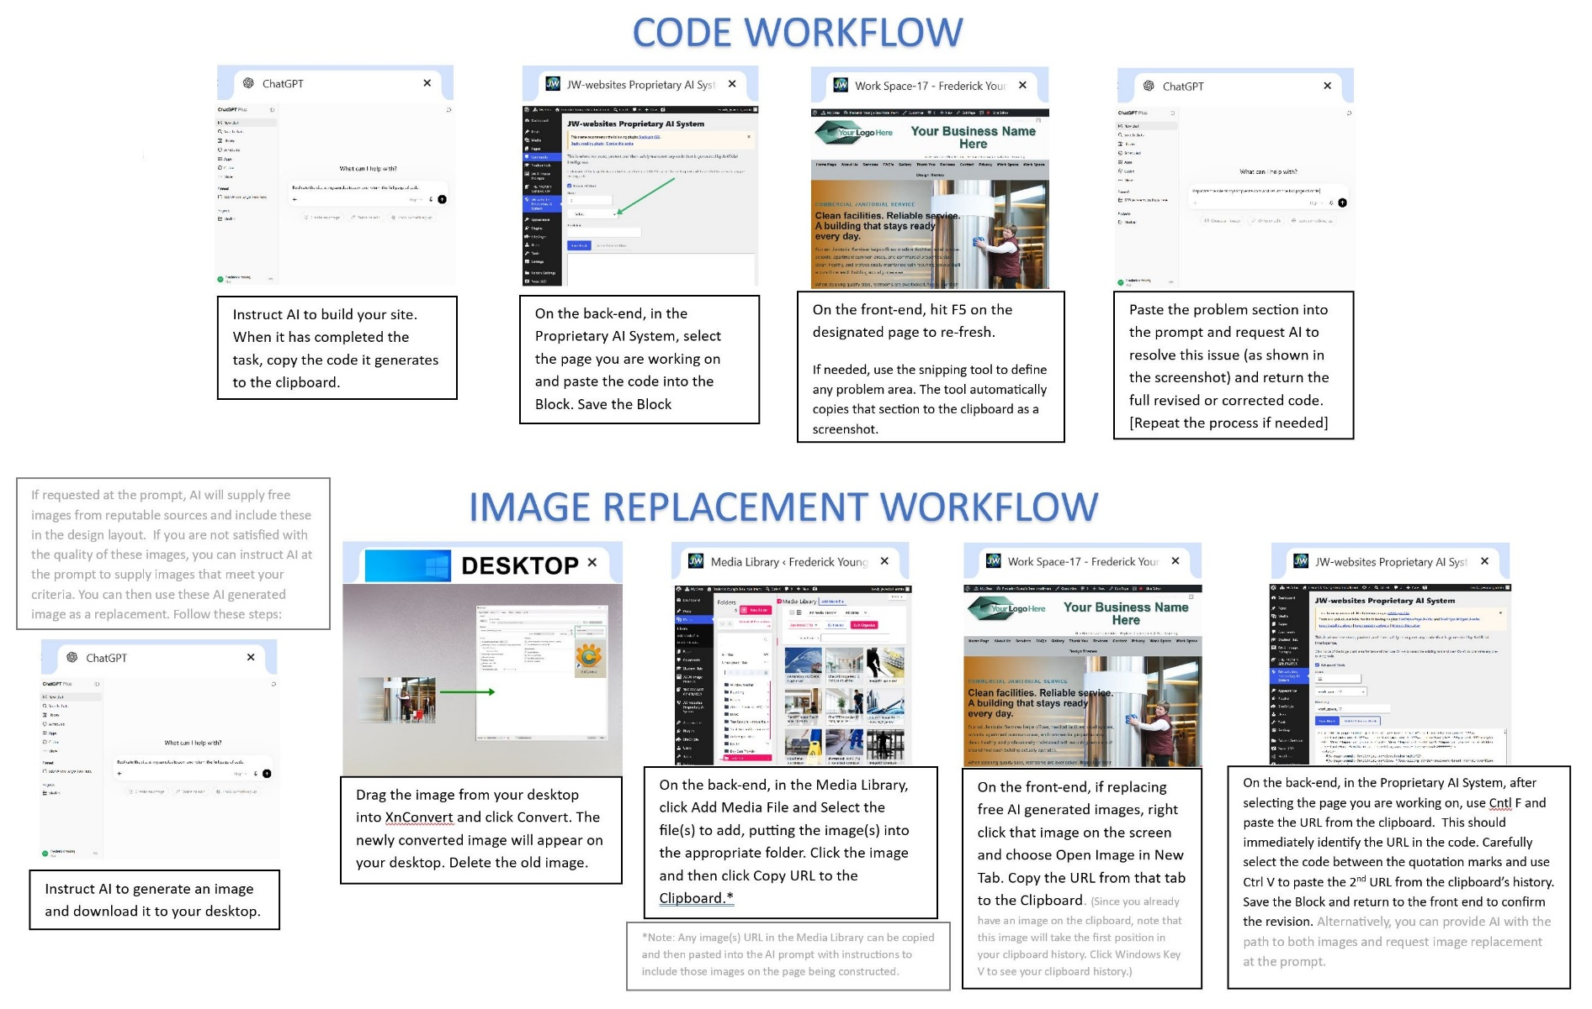
Visual Workflow Guide

How much should I charge?

We encourage you to use AI as an objective tool when negotiating with prospective buyers and establishing your website's asking price. An independent AI valuation provides a credible starting point based on the website's features, design, content, functionality, and overall market value.
Even if you decide not to use the AI-recommended price as your final asking price, the valuation serves as an unbiased reference point. If you choose to sell the website for less, buyers can clearly see that they are receiving a legitimate discount based on an independent assessment rather than an arbitrary price reduction. This added transparency helps build trust, strengthens your negotiating position, and can make buyers more confident in their purchasing decision. The next 2 pages are the value assessments generated by AI from this prompt:

Copy and paste the following into your AI prompt, inserting your website location or code:

Please provide an independent, professional assessment to establish the fair market value of the WordPress website located at: [INSERT WEBSITE ADDRESS – or copy the workspace code into the prompt]
The valuation should be fair, unbiased, and balanced, without favoring either the seller or the prospective buyer.
Review the site’s content, images, design, typography, mobile layout, navigation, functionality, and overall level of customization.
Write the report for a prospective buyer who may not be familiar with website pricing. Keep it brief, clear, and easy to understand, in that I will likely be sharing your research and assessment with the buyer.
Please include:
- A short overview of the website’s quality and scope
- The main features and work that add value
- Any visible issues that reduce its value
- A simple explanation of how the value was calculated
- Reliable 2026 pricing sources used for comparison
- A fair market value range and a recommended value
- A brief explanation of why the price is reasonable
Base the assessment on the website itself, not the seller’s asking price.

Independent Fair Market Value Assessment
Website: Clear Proof Testing Solutions LLC
Preview address: jwwebsites.com/frederick-young/workspace-30
Assessment date: July 13, 2026
Overall Quality and Scope
Clear Proof is a highly customized WordPress business website for drug testing, DNA testing, and background-screening services.
Although primarily presented as a long-form homepage, it contains the amount of design and content normally spread across several basic pages. The site includes a branded header, large hero presentation, service navigation, trust statements, detailed service descriptions, audience information, a four-step process, preparation guidance, frequently asked questions, multiple calls to action, and a custom footer.
The overall presentation is professional, modern, and appropriate for a business that must communicate confidentiality, accuracy, and trust.
Features and Work That Add Value
The strongest value comes from:
- A custom visual identity using coordinated navy, teal, aqua, and white styling
- A professionally designed hero section with layered imagery, animated accents, service messaging, and prominent calls to action
- Separate presentations for drug testing, DNA testing, and background screening
- Original, industry-specific written content rather than generic filler text
- A clear explanation of the service process and how customers should prepare
- Strong typography, visual hierarchy, numbered sections, cards, callouts, and information panels
- Responsive coding that restructures columns, cards, navigation, images, typography, and buttons for smaller screens
- Hover effects, subtle animations, lazy-loaded images, internal navigation, and repeated conversion points
- Compatibility with WordPress, SiteOrigin Page Builder, and the Vantage theme
The page also includes a professionally placed business logo and quality laboratory, document, and screening-related imagery.
Issues That Reduce the Value
The following factors prevent the website from being valued like a larger custom agency website:
- It is primarily one long homepage rather than a complete multi-page website
- The images are professionally selected stock photographs rather than original company photography
- The typography uses standard Arial and Helvetica fonts rather than a custom or licensed type system
- No online booking, payment system, customer portal, database, ecommerce system, or advanced integration is included
- The page itself does not contain a full inquiry form; visitors are directed to a separate contact page
- Service claims, availability, turnaround times, locations, and business details should be confirmed by the owner before final launch
- Because testing and background-screening services can involve legal and regulatory requirements, the final content should be reviewed for compliance in every location served
The supplied workspace address returned a 404 response to my external website checker on July 13, 2026. The page may still be available through an authenticated or internal preview, but public accessibility and all destination links should be confirmed before the website is presented or transferred to a buyer.
How the Value Was Calculated
The valuation compares the website with current professional WordPress and small-business website pricing and then adjusts the price according to its actual scope.
Current 2026 comparisons include:
- Clutch reports that most reviewed professional web-design projects cost less than $10,000, while web-design companies commonly charge approximately $100–$149 per hour.
- OuterBox lists professionally built small-business WordPress websites at approximately $2,500–$10,000 or more, with larger custom lead-generation websites beginning at higher levels.
- A 2026 small-business pricing guide from Flamingo Agency places most professionally built small-business websites at approximately $4,000–$8,000.
- Upwork places simple landing pages and basic theme installations much lower, generally $300–$1,000, but describes those projects as basic setups with limited customization.
Clear Proof is substantially more customized than a basic landing page or theme installation. However, its one-page scope and lack of advanced business systems keep it below the price of a complete custom multi-page website.
Fair Market Value
Reasonable fair market value range:
$4,500–$6,500
Recommended fair market value:
$5,500
This valuation assumes that the finished page is properly installed, publicly accessible, mobile-tested, and connected to working service and contact pages.
Hosting, domain registration, continuing maintenance, future revisions, original photography, search-engine campaigns, and separate service pages are not included unless specifically provided with the sale.
Why the Recommended Price Is Reasonable
A value of $5,500 reasonably reflects the considerable amount of professional design, industry-specific content development, image selection, responsive coding, WordPress implementation, navigation setup, animation work, and quality control represented by the page.
It also fairly recognizes the limitations: the evaluated work is primarily a custom homepage, uses stock photography, and does not include advanced customer, scheduling, payment, or database functionality.
This assessment is based on the Clear Proof website itself and current 2026 market comparisons—not the seller’s asking price.

